**ELECTRONIC VOTING SYSTEM**

### A PROJECT REPORT

Submitted in partial fulfillment for the award of the degree of

**B.TECH**

***in***

**Information Technology**

***by***

**MUDIT MAHESHWARI 13BIT0016**

**Under the Guidance of**

**Prof. Thanapal. P**



## School of Information Technology & Engineering

**MAY 2016**

**DECLARATION BY THE CANDIDATE**

I here by declare that the project report entitled **“ELECTRONIC VOTING SYSTEM”** submitted by me to Vellore Institute of Technology University, Vellore in partial fulfillment of the requirement for the award of the degree of **B.Tech.(Information Technology)** is a record of bonafide project work carried out by me under the guidance of **Prof. Thanapal. P.** I further declare that the work reported in this project has not been submitted and will not be submitted, either in part or in full, for the award of any other degree or diploma in this institute or any other institute or university.

Place: Vellore Signature of the Candidate

Date: Mudit Maheshwari



## School of Information Technology & Engineering [SITE]

###### CERTIFICATE

This is to certify that the project report entitled **“ELECTRONIC VOTING SYSTEM”** submitted by **Mudit Maheshwari (13bit0016)** to Vellore Institute of Technology University, Vellore in partial fulfillment of the requirement for the award of the degree of **B.Tech.(Information Technology)** is a record of bonafide work carried out by him/her under my guidance. The project fulfills the requirements as per the regulations of this Institute and in my opinion meets the necessary standards for submission. The contents of this report have not been submitted and will not be submitted either in part or in full, for the award of any other degree or diploma in this institute or any other institute or university.

**Prof . Thanapal P**

**SUPERVISOR Assistant Professor, SITE**

The Project Report is **Satisfactory / unsatisfactory**

**Name & Signature of the Examiners**

**Prof. Thanapal P Prof. Tapan Kumar Das**

**ACKNOWLEDGEMENT**

I heartfully thank **Prof G Viswanathan Chancellor VIT** for creating the infrastructure enabling working on the project.

I express my sense of gratitude to **Dr Anand Samuel, Vice Chancellor, VIT** for encouraging me to undertake projects by including these as part of course curriculum

I place it on record my sincere thanks to **Dr S Narayanan, Pro Vice chancellor, VIT** to enable me to do the project.

I sincerely thank **Dr Aswani Kumar, Dean (SITE)** for giving me the opportunity to undertake the project in SITE.

I express my extreme gratitude to **Dr Dinakaran HoD, IT** for allowing me to work on the project as part of my course curriculum in college.

I shall be failing in my duties if I do not thank **Prof G Thippa Reddy, co-ordinator** whose continuous guidance has enabled me to select and complete the project.

I am grateful to **Prof Thanapal P, Internal Guide** who has guided me at every stage of the project and without whose active and uninterrupted support it would not have been possible to complete the project.

**SYNOPSIS**

Voting systems are one of the finest examples of Embedded devices and applications. The complexity and robustness of a voting system depends on the number of voters involved. In this project a simple Arduino based voting system shall be designed that would be a great fit for small-scale elections such as in schools or colleges. The **highlighting feature** of this system is that **switches are used to perform the polling operation,** no other external devices and applications are needed. The close button is provided to prevent further voting after the polling process is completed. The contesting parties are displayed on the LED screen along with the total number of votes casted to them .The coolest thing is that whole voting process can be done with assembled hardware and Arduino IDE.

**I**

**LIST OF FIGURES**

**Figure No Title Page No.**

Fig. 1.1 Common Voting Process 2

Fig 4.1 Block diagram of Proposed System 8

Fig 4.2 Circuit design of proposed model 9

Fig 4.3 Circuit diagram of Connection of LCD to Arduino 12

**II**

**LIST OF ACRONYMS**

**Acronym Meaning Page No.**

1. EVM Electronic Voting Machine 1,2,8,10
2. BP Ballet Paper 2
3. addr addresses 3
4. DRE Direct Recording Electronic 3,4
5. CU Control Unit 10

**III**

**TABLE OF CONTENTS**

|  |  |  |
| --- | --- | --- |
| Chapter No | Contents | Page No |
|  | SYNOPSIS | I |
|  | LIST OF FIGURES | II |
|  | LIST OF ACRONYMS | III |
| **1** | **INTRODUCTION** | **1** |
| 1.1 | Background |  |
| 1.2 | Overview |  |
| 1.3 | Existing System |  |
| 1.4 | Problem statement |  |
| **2** | **OVERVIEW AND PLANNING** | **4** |
| 2.1 | Proposed System And Features |  |
| 2.2 | REQUIREMENTS |  |
| 2.2.1 | Hardware Requirements |  |
| 2.2.2 | Software Requirements |  |
| **3** | **LITERATURE SURVEY AND REVIEW** | **7** |
| 3.1 | Literature Survey |  |
| 3.2 | Literature Summary |  |
| **4** | **SYSTEM ARCHITECTURE AND DESIGN** | **8** |
| 4.1 | Block Diagram of EVM |  |
| 4.2 | Design Diagram of EVM |  |
| 4.2.1 | Detailed Description |  |
| 4.3 | Circuit diagram of connecting LCD to Arduino |  |
| 4.4 | Flow chart of the Process |  |
| **5** | **SYSTEM IMPLEMENTATION** | **14** |
| **6** | **RESULTS AND DISCUSSIONS** | **18** |
| **7** | **CONCLUSION** | **21** |
| **8** | **SCOPE OF FUTURE WORK** | **21** |
| **9** | **REFERENCES** | **22** |

**INTRODUCTION**

**BACKGROUND**

**VOTING**

People decide that who is going to rule or who gets the power through a process called “voting”. The voting is not a fresh idea rather it is as old as the history of mankind itself is. All over the history different methods and techniques of voting have been adopted. This system was designed like all concerned parties acting as candidates as well as voters that are polling the votes must be satisfied with the announcement of results after elections have been conducted. Atmosphere of voting and conducting elections basically depends upon the cultural values as well as political policies. A voting is a method in which voters make a choice between options, often in an election.

**VOTING SYSTEM**

The old methods of voting are also being changed to match the trends in the other fields of life. Now the current voting system is migrating from the conventional ballot papers and boxes to the microcontroller methods. Electronic Voting The term electronic voting is also called as e-voting which represents many different types of voting for both casting and counting of votes using electronic devices.

**ELECTRONIC VOTING**

The term electronic voting is also called as e-voting which represents many different types of voting for both casting and counting of votes using electronic devices. The EVMs reduce the time in both casting a vote and declaring the results compared to the old pb system.

1

**OVERVIEW**

**EVM stands for Electronic Voting Machine.** This makes polling much fast and ismore reliable than bp, by preventing bogus voting to a great extend.

The EVMs saves considerable time, money and manpower. It also helps in maintaining the secrecy of individual voting. At the end of polling, just press a button and there you have the result

**PICTORIAL DEPICTION OF VOTING**

goes to the polling placeidentifies the user indicates ready status to vote

Selects candidate of his choice indicates selection

On ballot unit

leaves the polling place provides confirmation to the voter and casts the vote

-------candidate

------- admin

Fig 1.1 Common Voting Process

2

**EXISTING SYSTEM**

**PAPER BASED**

In 2013 Atiya Parveen1, Sobia Habib2, Saoud Sarwar3, worked on “Scope and Limitation of Electronic Voting System.”In Paper Based Process the election workers will visit the residential addr. to ensure that those persons actually live there and ascertain that they have given the correct information about themselves. After validation, a Identification card will be issued to the voter.

**CONS:-**

* A lot of paper work was concerned in the whole procedure.
* Appropriate training will be required for the staff members in charge of polling duty.
* At polling date, the concerned staff members are required to be present half hour prior to the opening of the polling booth/station to check that all arrangements have been done correctly.

**PUNCH CARD BASED**

In 2007 Michael D. Byrne, Kristen K. Greene, Sarah P. Everett, propose a scheme called “Punch Card Method” based on the Votomatic system. This system uses a special cards where each possible hole is pre-scored and allowing perforations to be made by the voter pressing a stylus through a guide in the voting machine. Scoring of the punch cards was also done by hand and not by a punch card reader

**CONS:**

* A problem with this system is the incomplete punch which can lead to a smaller hole than expected

**DIRECT RECORDING ELECTRONIC VOTING SYSTEM**

A public network DRE voting system is an election system that uses electronic ballots and transmits vote data from the polling place to another location over a public Network. The Vote data may be transmitted as individual ballots as they are cast or periodically as batches of ballots throughout the Election Day or as one batch at the close of voting. This scheme includes Internet voting as well as telephone voting. Two methods are used in Public network DRE voting system they are pre count or central count method. The central count method forms a table from multiple precounts at a central location. The Internet voting can use remote locations (voting from any Internet capable computer) or can use traditional polling locations with voting booths consisting of Internet connected computers. Corporations and organizations can use Internet voting to elect officers and Board members and for other proxy elections.

**CONS:**

* Expensive
* Use of telephonic network, private computer network and internet.

3

**OVERVIEW AND PLANNING**

**PROBLEM STATEMENT**

**The Paper Based Process** is Time Consuming.

**Problem with Punch Cards** is the incomplete punch; this can lead to a smaller hole than expected.

In **Paper-based electronic voting s**ystem This process can be boring and error prone and costly.

In **Direct-Recording Electronic** (DRE) voting system the problems can be

1. Expense

2. They will still ultimately fail if there are substantial usability problems

3. Use of telephonic network, private computer network and internet.

**In Public Network DRE Voting System,** the problem can be**:**

• System Frustrated workers attempting to determine voter intent from ambiguous punch cards.

4

**PROPOSED SYSTEM**

The voting machine design proposed in this system is appropriate. The count of the total number of votes casted so far can be known by pressing the total switch. Close button when pressed closes the voting process and if this button is pressed then polling buttons will become ineffective and pressing of these three buttons will not have any effect on the system. Once close button is pressed, the result will be displayed for 5 seconds after that voting shall be closed that is no other input will work. The Result button shall display the name of the winning party .

. The contesting parties are displayed on the LED screen along with the total number of votes casted to them

**FEATURES OF PROPOSED SYSTEM**

**Following are some of the features of the proposed system**

**Reduced Cost:**

There is no need of purchasing the ballot papers. As the voting results are generated electronically , there is no need of man power to compute the voting results.

**Voter’s intent:**

Voter’s intent can besuccessfully determined using immediate feedback system.

**Transparency**:

Electronic voting reduces the possibility of fraud on largescale. Because its code is not accessible and cannot bechanged once it is burnt.

5

**REQUIREMENTS**

1. **HARDWARE REQUIREMENTS**

* ARDUINO UNO
* 2* 16 LCD DISPLAY
* PUSH BUTTONS (7)

1. 3 FOR CASTING VOTES
2. 1 FOR CLOSING THE POLLING
3. 1 FOR DISPLAYING RESULTS
4. 1 FOR DISPLAYING TOTAL VOTES

* BREADBOARD
* POTENTIOMETER
* SOLDERING GUN
* CONNECTING CABLES

1. **SOFTWARE REQUIREMENTS**

* Arduino IDE

6

**LITERATURE SURVEY AND REVIEW**

**VOTING TECHNOLOGIES**

**Traditional paper ballot**: The most basic form is using blank piece of paper upon which a voter writes his choice of candidates. The voter then seals his vote inside an envelope, places his ballot into a box, which when elections end, is opened and votes are counted. An election conduced using the Australian secret ballot is only trustworthy, if every ballot is strictly accounted for and no blank ballots escape the control of the election officials. Because we expect each official to have partisan interests, ballots must never be handled by one official without close supervision from someone representing an opposing political party. The greatest weakness in this scheme, lies in the way that votes are counted.

**Lever Voting Machines**: Mechanical voting machines were first introduced in 1892 in New York. This technology was soon after adopted by most urban centers across the US, as they were believed not to be subject to bias in counting, and secondly because they seemed to offer instant election results.

**Punch card voting**: The ballot is a form of the traditional Australian ballot, designed to be tallied using standard punch card data processing equipment and with a mechanical aid. Used to ensure that votes are cast in a uniform manner. These systems (Votomatic system is most widely used), have several drawbacks, most critical being the way votes are punched. The system punches holes on a ballot to show voter intention.

Incompletely-punched holes resulted in partially-punched chad, where one or more corners were still attached, a hanging chad, dimpled chad or pregnant chad - where all corners were still attached, but an indentation appears to have been made. These votes were not counted by the tabulating machines (6,358 out of 433,043).

**Literature Review:**

We came across the traditional paper ballot system in which the voter was expected to write the name of the contestant whom he/she is supporting. The lever voting machines provided instant election results. In the punch card voting ,people were expected to make a hole on the ballot against the name of the contestant.

7

**SYSTEM ARCHITECTURE AND DESIGN**

**BLOCK DIAGRAM FOR THE EVM**

**MICROCONROLLER**

**ARDUINO UNO**

16*2 LCD DISPLAY

CONTROL DATA LINES

LINES

Fig 2.2 Block diagram of Proposed System

8

**DESIGN OF PROPOSED SYSTEM**

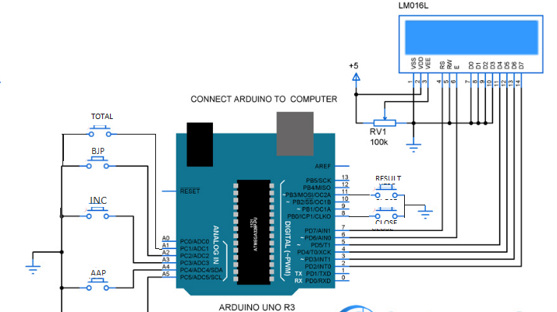

Fig 2.3 Circuit design of proposed system

9

**DESIGN DESCRIPTION IN DETAIL**

Generally EVM has two parts-

1. Control Unit
2. Ballot Unit

CU stores all the votes in the memory and is generally battery operated. CU also contains important buttons like result, close, print, clear. Ballot unit contains buttons of the contesting parties. A connecting cable is used for connecting ballot unit with the control unit.

The “Electronic Voting Machine” basically consists of three main components. These components are Push buttons, Microcontroller and LCD Display.

1. **PUSH BUTTON**:

The functionality of the push button is used in 5 ways:

* 1. **CASTING BUTTON**

The candidates will push the button corresponding to the party they want to vote for.

**1.2 TOTAL BUTTON**

Total button can be pressed any time to get the count of the total number of votes that are polled so far

**1.3 CLOSE BUTTON**

Close button if pressed closes the voting process and if this button is pressed then polling buttons will become in effective and pressing of these three buttons will not have any effect on the system. Once the close button is pressed, result will be displayed and then voting will be closed that is no other input can be given.

**1.4 RESULT BUTTON**

Once the Result button is pressed the machine will tell you the exact number of votes that are polled for each of the three contesting parties and it will also tell the result of the poll that is which party has won the election. The machine is programmed to also indicate the vote difference b/w the winning party and the first runner up party. In case tie happens b/w any two parties, or b/w all three contesting parties then the machine will show the tie result on the lcd screen.

10

1. **MICRO CONTROLLER—ARDUINO :**

Based on the output signal from switches the micro controller decides the mode of operation. Micro controller fetches the data from display mode to memory location block to indicate one key is pressed. A program which keeps the count of each vote for a specific party is designed. This program is then loaded into the microcontroller by using the Arduino IDE. The program has been designed such that on clicking the result button the name of the party which wins is displayed on the LCD Screen and also the difference between the votes of the winning party and the first runner up is shown.

1. **LCD DISPLAY**:

LCD is commonly known as Liquid Crystal Display it is also called as an Alphanumeric Display which means that it can display Alphabets (A-Z and a-z), Numbers (0-9) as well as special symbols. This is a user friendly Display device which can be used for displaying various messages unlike seven segment displays which can display only numbers (0-9) and some of the alphabets there are two types of LCDs that are available. They are: graphical LCDs and character LCDs. For this project character LCD is being used as it is the easiest to work on. Also, based on the size of the LCD, there are different types of them

. Some of the most commonly used are:

1. 16×2 character LCD (16 columns and 2 rows).
2. 20×4 character LCD (20 columns and 4 rows).

And they are also available in different colors:

1. Green LCDs with black characters.
2. Blue LCDs with white characters.
3. Red LCDs with black characters.
4. And many more.

However, green and blue LCDs are the most common ones.

The seven segment display is robust and be visualized from a longer distance as compared to LCD. The 16 x 2 alphanumeric displays can show two lines with maximum of 16 characters in one line

1. **POTENTIOMETER**

Potentiometer is used for interfacing the LCD with the arduino. Potentiometer acts as a voltage divider between the arduino and the LCD display. It allows only limited voltage to pass through the LCD display.

11

**CIRCUIT DIAGRAM FOR CONNECTING LCD TO ARDUINO**

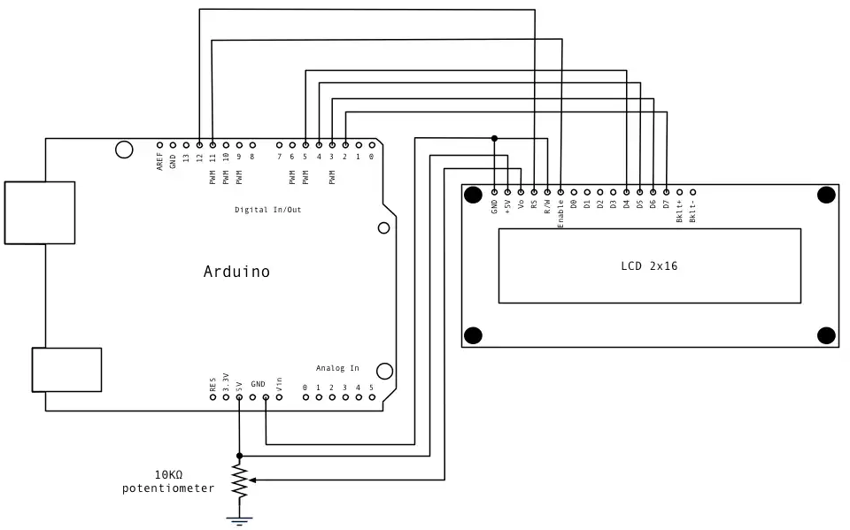

Fig : Circuit diagram of Connection of LCD to Arduino

12

**FLOW CHART OF THE PROCESS**

START

VOTE

CHOOSE

CLOSE

AAP

TOTAL

BJP

INC

VOTE1++

VOTE3++

VOTE2++

RESULT

WINNING PARTY

AAP

BJP

INC

STOP

13

**SYSTEM IMPLEMENTATION**

**CODE**

#include<LiquidCrystal.h>

LiquidCrystal lcd(12, 11, 5, 4, 3, 2);

#define sw1 10

#define sw2 9

#define sw3 8

#define sw4 7

#define sw5 6

#define swclose 13

int vote1=0;

int vote2=0;

int vote3=0;

//int vote4=0;

int totvote=0;

void CalcResult(int vote1,int vote2,int vote3){

int vote=vote1+vote2+vote3;

if(vote)

{

if((vote1 > vote2 && vote1 > vote3 ))

{

lcd.clear();

lcd.print("BJP Wins");

delay(2000);

lcd.clear();

}

else if((vote2 > vote1 && vote2 > vote3 ))

{

lcd.clear();

lcd.print("INC Wins");

delay(2000);

lcd.clear();

}

else if((vote3 > vote1 && vote3 > vote2 ))

{

lcd.clear();

lcd.print("AAP Wins");

delay(2000);

lcd.clear();

}

else

{

14

lcd.clear();

lcd.print(" Tie Up ");

lcd.setCursor(0,1);

delay(1000);

lcd.clear();

}

}

else

{

lcd.clear();

lcd.print("No Voting....");

delay(1000);

lcd.clear();

}

vote1=0;vote2=0;vote3=0;vote=0;

}

void setup()

{

pinMode(sw1, INPUT);

pinMode(sw2,INPUT);

pinMode(sw3,INPUT);

pinMode(sw4,INPUT);

pinMode(sw5,INPUT);

pinMode(swclose,INPUT);

lcd.begin(16, 2);

lcd.print("Voting Machine");

lcd.setCursor(0,1);

lcd.print("Mudit Maheshwari");

delay(3000);

digitalWrite(sw1, HIGH);

digitalWrite(sw2, HIGH);

digitalWrite(sw3, HIGH);

digitalWrite(sw4, HIGH);

digitalWrite(sw5, HIGH);

digitalWrite(swclose,HIGH);

lcd.clear();

lcd.setCursor(0,0);

lcd.print("BJP");

lcd.setCursor(4,0);

lcd.print("INC");

lcd.setCursor(8,0);

lcd.print("AAP");

}

void loop()

{

15

lcd.setCursor(0,0);

lcd.print("BJP");

lcd.setCursor(1,1);

lcd.print(vote1);

lcd.setCursor(4,0);

lcd.print("INC");

lcd.setCursor(5,1);

lcd.print(vote2);

lcd.setCursor(8,0);

lcd.print("AAP");

lcd.setCursor(9,1);

lcd.print(vote3);

if(digitalRead(sw1)==0)

vote1++;

while(digitalRead(sw1)==0);

if(digitalRead(sw2)==0)

vote2++;

while(digitalRead(sw2)==0);

if(digitalRead(sw3)==0)

vote3++;

while(digitalRead(sw3)==0);

/*computing result*/

if(digitalRead(sw4)==0)

{

CalcResult(vote1,vote2,vote3);

lcd.clear();

}

if(digitalRead(sw5)==0)

{

totvote=vote1+vote2+vote3;

if(totvote){

lcd.clear();

lcd.print("Total votes");

lcd.setCursor(0,1);

lcd.print(totvote);

delay(1000);

lcd.clear();

}}

if(digitalRead(swclose)==0)

{

lcd.clear();

CalcResult(vote1,vote2,vote3);

lcd.print("Voting Closed");

delay(200000);

lcd.clear();

}}

16

**TESTING**

The code was tested with many test cases such as when the vote count was equal for at least 2 parties, or when no votes were provided. These extreme test cases were handled efficiently by the program . It did not result in crashing of the program. All the test were successfully applied and the expected results were obtained.

**TEST CASES**

|  |  |  |
| --- | --- | --- |
| **TEST CASE NUMBER** | **TEST CASE** | **RESULT** |
| 1. | BJP=8,INC=7,AAP=5 | BJP WINS |
| 2. | BJP=5, INC=10,AAP=6 | INC WINS |
| 3. | BJP=8,INC=12,AAP=20 | AAP WINS |
| 4. | BJP=2,INC=2,AAP=9 | AAP WINS |
| 5. | BJP=8,INC=0,AAP=8 | TIE UP |
| 6. | NO INPUT | NO VOTING |

17

**RESULT AND DISCUSSION**

**OUTPUT ANALYSIS**

The program successfully was run using the Arduino IDE. The LCD display showed the names of the contesting parties. The name of the winning party was also displayed on the LCD display.

**SNAPSHOTS**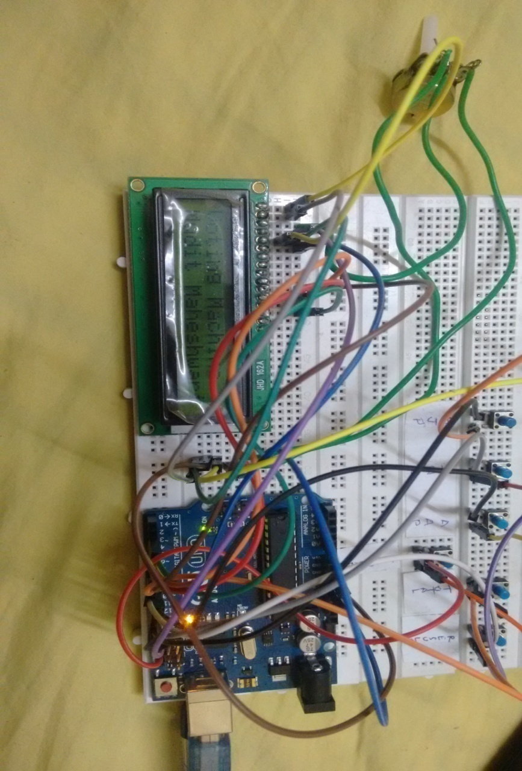

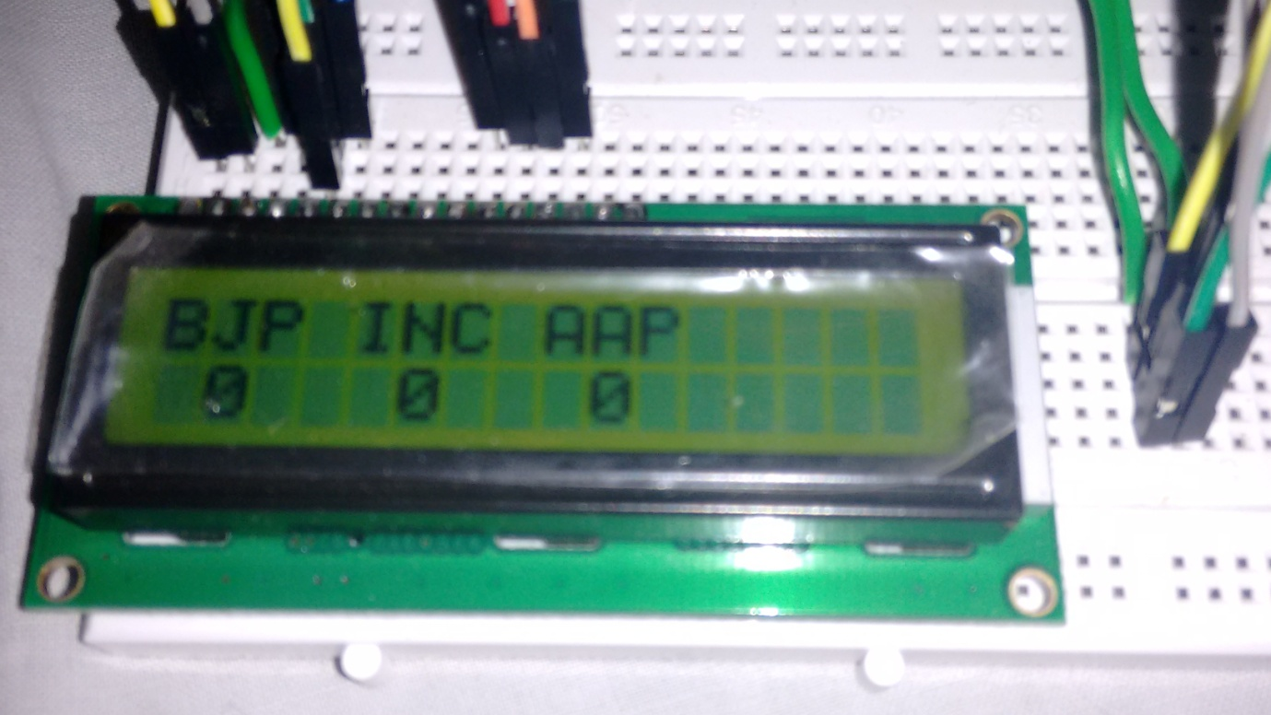

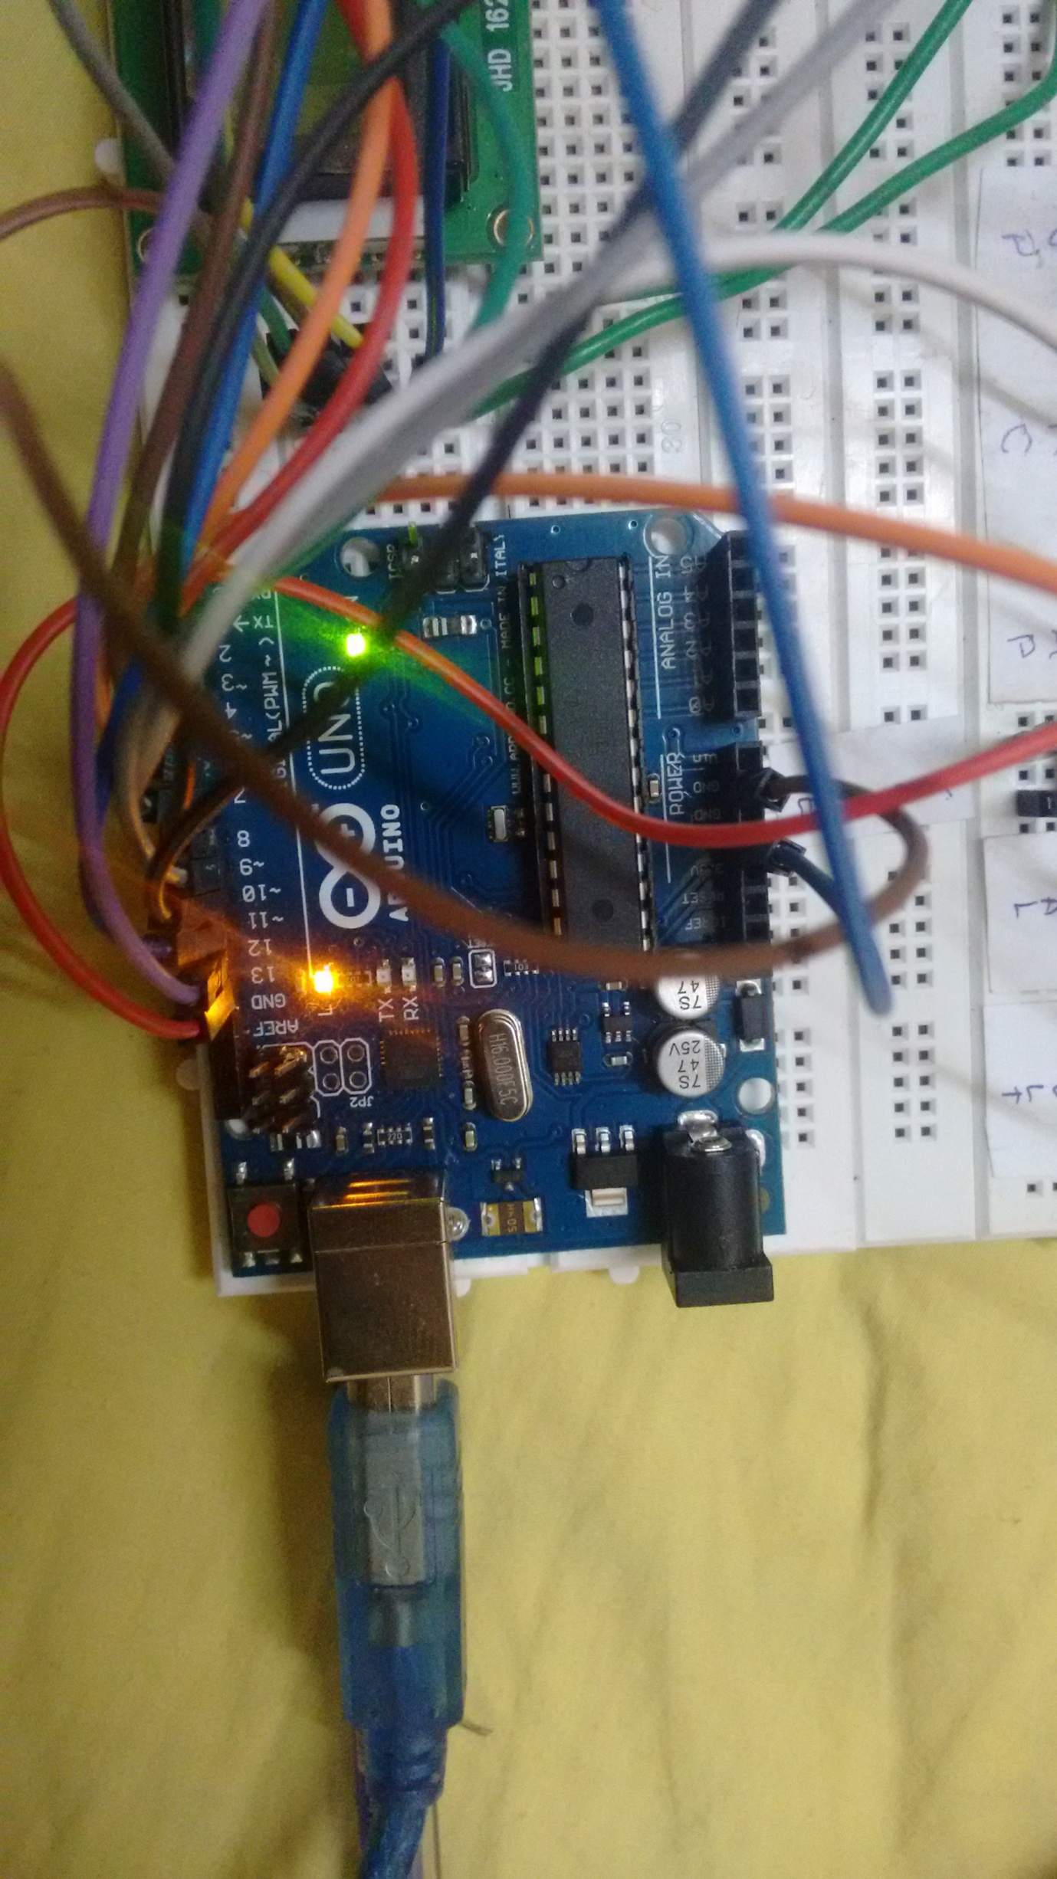

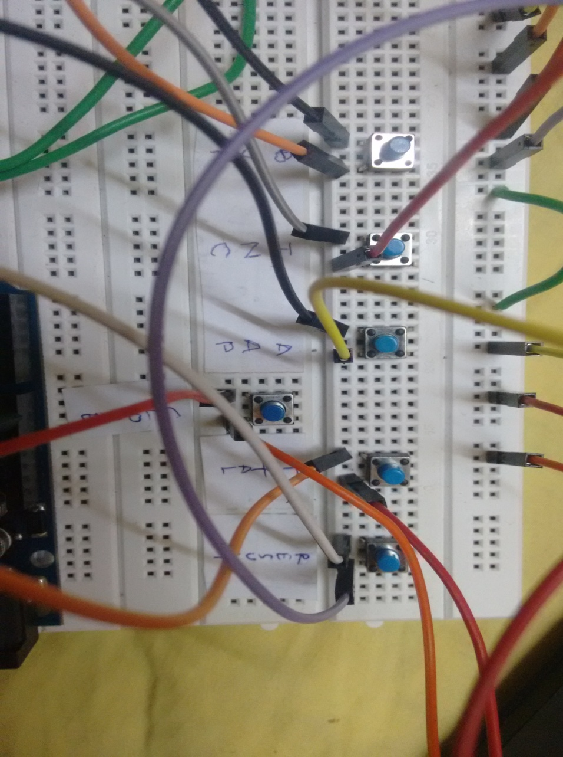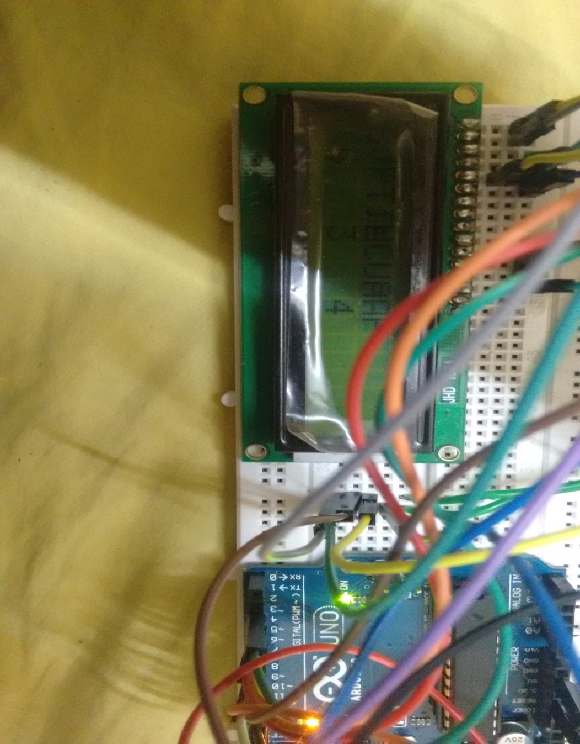

**DISCUSSIONS**

The code has been designed such that whenever a user tries to press result without casting any vote, The LCD display showed No voting. If two or more parties get the same number of votes, then the LCD displays Tie Up which is an expected result. When the close button is pressed, the voting stops and no other votes can be casted thereafter.

**20**

**CONCLUSION**

The project can be used for small scale voting since it overcame all the drawbacks of the ordinary voting system. Its main advantage is that the system is easy to use and does not make use of any complex hardware which require a lot of knowledge prior to use them. The system can be manufactured simply as well as it is cheap.

**FUTURE WORK**

The proposed system can be extended by using more than 3 parties to cast vote. *The vote count can be stored in a SD card so as to maintain the voting results* even after no power is supplied to the arduino. Instead of push buttons, Keypad can also be used to cast the votes. Serial monitor can be used to incorporate the security needed for voting or a finger print scanner module can be used to incorporate a greater level of security.

**21**

**REFERENCES**

**JOURNALS**

* 1. Volume 3, Issue 1, January 2013 Mr. Mayur Patil, Mr. Vijay Pimplodkar, Ms. Anuja R. Zade, Mr.Vinit Vibhute, Mr..Ratnakar Ghadge Department of Information Technology Rajarshi Shahu College of Engineering Pune, India A Survey on Voting System Techniques International Journal of Advanced Research in Computer Science and Software Engineering
  2. Volume 3, Issue 12, December 2014 S.V.Prasath, R.Mekala M.E. (Ph.D.) 1PG Student, INFO Institute of Engineering, Coimbatore 2Assistant Professor,INFO Institute of Engineering, Coimbatore International Journal of Advanced Research in Electronics and Communication Engineering (IJARECE) A LITERATURE SURVEY ON MICRO-CONTROLLER BASED SMART ELECTRONIC VOTING MACHINE SYSTEM
  3. 2007-2011 Dimitrios Zissis Methodologies and Technologies for Designing Secure Electronic Voting Information Systems
  4. “Electronic Voting,” Ronald L. Rivest, Technical Report, Laboratory for Computer Science, Massachusetts Institute of Technology.

**CONFERENCE PAPERS**

1. Dix A., “Electronic democracy and its implication for political privacy”, 23rd International Conference of Data Protection Commissioners, September 2001, Paris.

**22**